c. Admin – Jun Lee

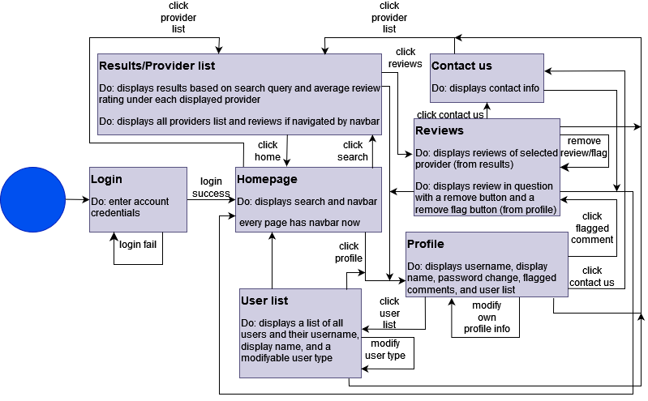

4. Database schema

c. Admin – Jun Lee

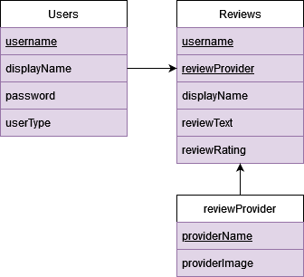

5. Software architecture – MVC

c. Admin – Jun Lee